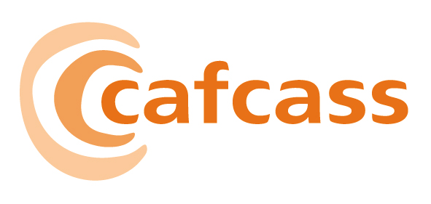

CHILDREN AND FAMILY COURT ADVISORY AND SUPPORT SERVICE

Paper for the Board meeting on 01 December 2006

Safeguarding Framework

1 AIM AND PURPOSE

1.1 To seek the approval of the Board for the Safeguarding Framework.

2 ACTION FOR THE BOARD

2.1 To consider and ratify, subject to any further amendments, the Safeguarding Framework

3 RECOMMENDATION

3.1 That the Framework be endorsed.

4 KEY STRATEGIC ISSUES FOR THE BOARD TO CONSIDER

4.1 Following an HMICA report in 2005 recommending that all relevant CAFCASS policies be brought together into a single framework the draft Safeguarding Framework was completed, and put out for consultation in the three months leading up to 7th August 2006. The overall response has been very positive, with detailed feedback received from twenty-seven external organisations, and from fifteen individuals or groups internal to CAFCASS (a full list is attached).

4.2 The Safeguarding framework (Appendix 1) sets out what ‘safeguarding’ means for CAFCASS as an organisation. Within it many existing policies have been pulled together. These include:

- Child protection policy and procedures
- Information sharing procedures
- Serious case review procedures
- Links to the Domestic violence policy
- Implications for staff who are subject to allegations of misconduct
- Guidelines on our analytical role in screening and risk assessment

4.3 The document sets all of the above in a context of children’s rights and diversity. In addition to the policies listed above, a ‘resource pack’ is also included, pulling into one place useful forms, aide memoirs, flow charts and legislation updates relevant to the policies included in the document.

  - Revision of the document in response to consultation feedback has involved:

- Making minor detailed amendments to many sections (clarity of wording, etc)
- Re-structuring the document to better reflect the organisation’s priorities
- Ensuring conformity with Working Together to Safeguard Children 2006
- Improving the readability by better identifying policy, guidelines, background information and organisational ethos.

4.5 The re-drafted version of this document is now presented to the Board in the week before the Board meeting, there are another two important meetings: the national safeguarding regional reps meeting, and extended CDG. Any further amendments arising from these meetings will be presented to the Board on 1st December, as last minute amendments to the main document.

5 FINANCIAL IMPLICATIONS

5.1 Provision has already been made for costs associated with circulation of the Framework. Tools to assist with roll-out and implementation are being provided to team managers electronically. Induction and Foundation training course content has been revised to reflect the contents of the Framework at no additional cost.

6 RISKS

6.1 Failure to provide appropriate policies and procedures in relation to safeguarding children increases the vulnerability of service users and exposes the organisation to an increased risk in relation to the quality of services.

Jane Booth
Corporate Director

16 November 2006

