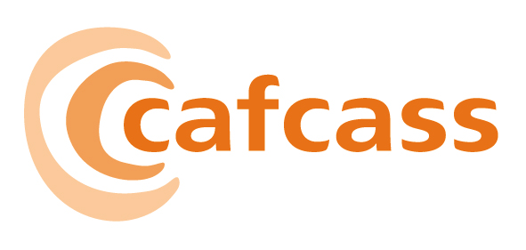

CHILDREN AND FAMILY COURT ADVISORY AND SUPPORT SERVICE

Paper for the Board meeting on 09 March 2007

NATIONAL STANDARDS

1 AIM AND PURPOSE

1.1 The purpose of this report is to provide the Board with the Final National Standards.

2 KEY ISSUES FOR THE BOARD TO CONSIDER

2.1 3 short e-mails were the only further responses to the draft National Standards, following the significant re-write after the previous consultation back in the summer of 2006. The lack of responses indicates the fact that the extensive re-write did satisfy most concerns, although some points of principle remain for a small number of stakeholders. The organisation moved on in respect of the Standards a few months ago, to a position of broad acceptance, and we have recently evaluated tenders for a training package to support the Standards. The final version of the Standards does change a few words to increase clarity but is fundamentally unchanged from the version sent out with the Organising for Quality consultation paper.

3 Action for the Board

3.1 This version is now recommended to the Board for final sign off.

Anthony Douglas
6 March 2007

