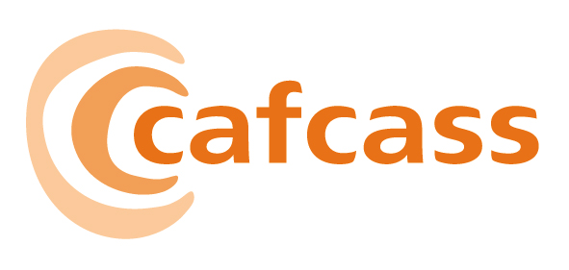

CHILDREN AND FAMILY COURT ADVISORY AND SUPPORT SERVICE

Paper for the Board meeting on 09 March 2007

The 2007-2010 Strategic Business Plan

1 AIM AND PURPOSE

1.1 The purpose of this report is to provide the Board with the new three year Strategic Business Plan for Cafcass.

2 ACTION FOR THE BOARD
  - To make comment before a final version is presented to the DfES.

3 KEY ISSUES FOR THE BOARD TO CONSIDER

3.1 This is a 3 year strategic Plan. It was developed through a collaborative exercise involving staff at all levels of the organisation. ECDG approved it with amendments on the 28th of February, and all amendments have been incorporated into this version. Around 150 people including young people have helped to shape it.

3.2 However, we have not yet received our budget allocation for 2007/08 and will need to ensure that we can deliver our objectives within resources, when they are allocated.

3.3 The Business Plan has been cross-referenced to all major documents & strategies:
- National standards/Organising for Quality
- Workforce (draft)
- KLD
- Equality and Diversity
- Engagement and Participation
- Communications
- IT and Property

3.4 The vision statement is the same as the one set out in the National Standards. In addition, there are four values set out, which try to succinctly capture some of the ways in which we are setting about the changes in Cafcass:

- Passion – Engage with children and families so what we do is determined by their needs
- Equality – we believe all children and young people have equal worth and equal rights
- Honesty and openness - measure and account for what we do so that our performance is open to scrutiny; welcome feedback on our work and provide a transparent procedure for complaints
- Pragmatism - Seek the best we can for all the children and families we serve within the resources available to us.

3.5 We have ten objectives, which we have grouped under three broad themes to help us achieve our primary purpose. The following is a summary:

Theme 1: Delivering excellence in all we do

Objectives:

Provide a high quality, cost effective, safe and culturally competent service to children and families.

Deliver on our National Standards

Continually shape improvements to our service, which are informed by how our service users and stakeholders perceive our service.

Develop effective and collaborative partnerships that will facilitate the delivery of positive outcomes for children and families.

Theme 2: Developing and Supporting our workforce
Objectives:
- Create a positive organisational culture, which values, respects and empowers employees and where employees champion the values and principles of Cafcass.
- Ensure that the shape, skills and capacity of the workforce is right to deliver our services
- Develop our leadership capacity so that it supports organisational and staff improvement and effective delivery of services.

8. Implement a people strategy that recruits, rewards, retains and develops a flexible and diverse workforce, which reflects the communities we serve and makes Cafcass the leading employer for staff in our sector.

Theme 3: Delivering Value
Objectives:
- To provide the tools, skills and confidence to enable Cafcass to be a credible and professional organisation.
- Being more efficient and adding value in all we do.

3.6 These objectives form the basis of our work plan for the next three years - 2007-2010. We have set out our priorities and milestones to be achieved for each of these. However we will review this each year against the external and internal context, to ensure that they remain the right ones for us to follow through.

- Next Steps

4.1 The new risk register relating this plan will be developed during March and April and Board approval will be sought at the April Board meeting. Once Board have approved this Business Plan it will be sent to DfES for Secretary of State approval.

Sherry Malik

Corporate Director, Strategy and Performance

March 2007

