
 PIONEER INDUSTRIAL PARK
Bilaspur Chowk, Pathredi, Gurgaon (NH-08)

W.e.f. 13/02/2008
PRICE LIST PAYMENT PLANS

A. Down Payment Plan ( With 8% Rebate )
S.NO | Plot Sizes  (In Sq.yds) | Basic Rate  (Rs.) | Booking Amount 15% (Rs.)
1 | 1200 | 12500/- | 22,50,000/-
2 | 2400 | 12000/- | 43,20,000/-
3 | 3200 | 12000/- | 57,60,000/-
4 | 4840 | 12000/- | 87,12,000/-
On booking : 15%
Within 45 days of booking : 80% Less Rebate
On offer of possession : 05%

B. Interest Free Installment Plan
On booking : 15%
Within 1 ½ months from the date of booking : 15%
Within 3 months from the date of booking : 15%
Within 4 ½ months from the date of booking : 15%
Within 6 months from the date of booking : 15%
Within 7 ½ months from the date of booking : 10%
Within 9 months from the date of booking : 10%
On offer of possession : 05%

____________________________________________________________________________________________
Preferential Location Charges : Corner 2.5%
Sector Road 5.0%
Corner +Sector Road 7.5%
Note:
- The prices are firm and free of escalation charge.
- Cheques / Bank Drafts to be issued in favour of “Ansal Properties & Infrastructure Ltd.” payable at Delhi/New Delhi banks only. Outstation cheques shall not be accepted.
- Prices are subject to revision without notice and price ruling on the date of booking and acceptance by the company only shall be applicable.
- EDC/Infrastructure charges shall be in addition to the basic sale price.
- Other terms & conditions shall be as per the allotment letter.
- The buyer shall abide by all the terms & conditions as imposed by the approving authority.
- The Registration charges, legal documentation charges are in addition to the aforesaid prices.
S.NO | Plot Sizes  (In Sq.yds) | Basic Rate  (Rs.) | Booking Amount 15% (Rs.)
1 | 1200 | 12500/- | 22,50,000/-
2 | 2400 | 12000/- | 43,20,000/-
3 | 3200 | 12000/- | 57,60,000/-
4 | 4840 | 12000/- | 87,12,000/-
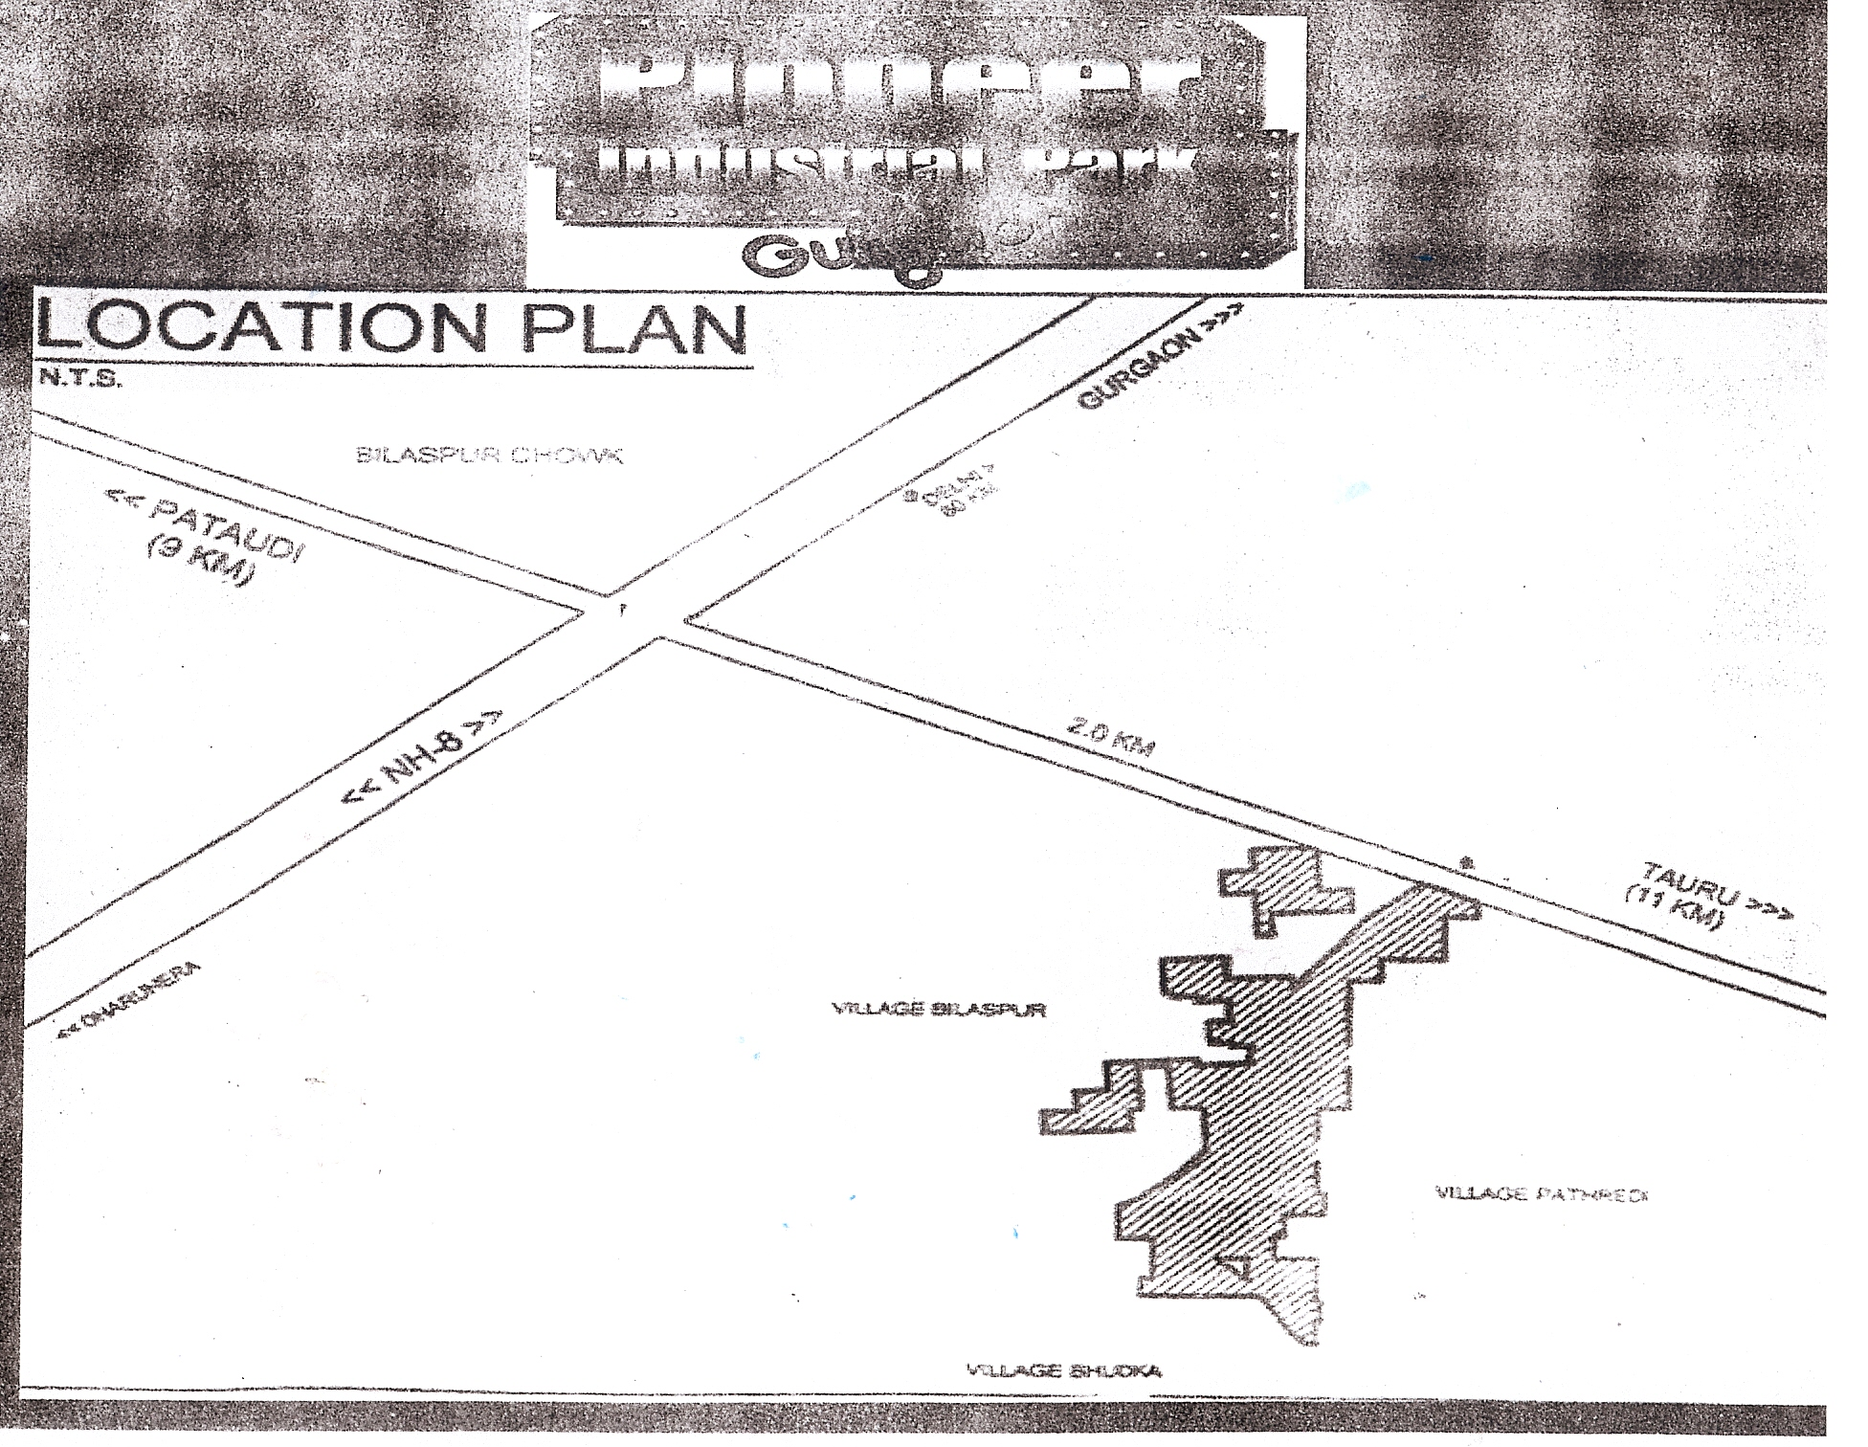
READY INFRASTRUCTURE |  | SPECIAL INCENTIVES
- Landscaped open area  - Wide Roads and Electricity  - Hi- tech Security  - Special Truck Terminal  - Gas Station, Fire Station | - Sewage treatment plan  - Reliable power and Water Supply  - Housing, Bank, ATM, Post Office  - Well Planned and environment friendly infrastructure | - Mega projects of 100 crore plus or employing 500 persons plus to be extended Interest Free Load repayable after 5 Years.  - SSIs to be extended Interest Free Load repayable after 5 years.  - Special subsidy for Exporting Units up to 1% of the FOB value of exports subject in max, Rs. 10 lac per annum

INDUSTRIAL MODEL TOWNSHIPS
HSIDC has developed an industrial model townships on modern lines. This has been a very successful venture and has been welcomed by user industry. It is proposed to replicate the development and put up two IMTs during the next five years at suitable locations in the state each comprising of an initial area of about 2000 acres.
These township shall draw upon the experience of IMT Manesar and shall include campuses for large industries, ICT parks, industrial plots, flatted factories, residential colonies, labour housing, commercial and institutional areas, entertainment zones, educational & health care facilities etc. The development will be of international standard with power, water supply, roads, sewerage, effluent disposal, storm water disposal, and solid waste management to enable enterprises to function in a pleasing environment.

INCENTIVES FOR MEGA PROJECTS IN BACKWARD ARES
i) Mega project with investment of Rs.100 crore and above or any project employing more than 500 persons irrespective of investment to be set up in the backward areas would be extended the facility of financial assistance to be quantified at, 50% of the tax paid on the sale of goods produced by such industrial units, under the Haryana Value Added Tax Act 2003 for a period of 7 years from the date of start of commercial production, as Interest Free Loan (IFL) repayable after a period of 5 years from the date of grant of IFL.
ii) Exemption from LADT for a period of 5 years
Incentives for SSI in Backward Areas
New SSI units in the backward areas would be extended the facility of financial assistance in the shape of Interest Free Loan to be quantified at, 50% of the tax paid on the sale of goods produced in such industrial units, under the Haryana Value Added Tax Act 2003 for a period of 5 years from the date of start of commercial production to be repayable after a period of 5 years.
Incentives for Exporting Units
In order to boost the exports and enhance competitiveness of exporting units, subsidy up to 1% of the FOB value of exports subject to maximum of Rs.10.00 Lac per annum shall be given.

